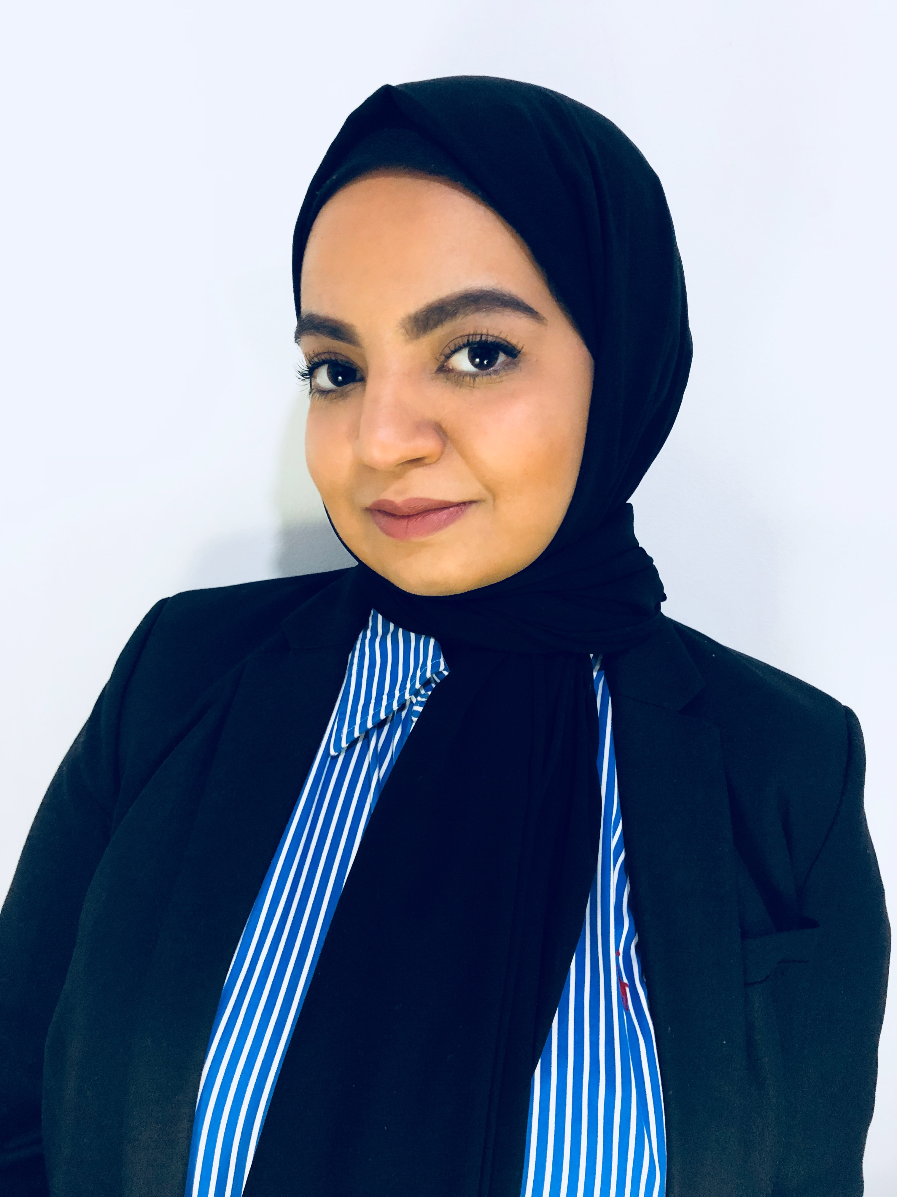
Noora Ebrahim Zowayed
: 33 80 77 02
: noorazowayed12@gmail.com

- PERSONAL INFORMATION:
Name | : Noora Ebrahim Abdulrahman Zowayed
Nationality | : Bahraini
Date of Birth | : 28th December 1992
CPR no. | : 921203896
Gender | : Female
Marital Status | : Single
Parents | : Ebrahim Abdulrahman & Mona Mohamed Al-Mulla
Address | : Villa 128, Road 902, Block 109, Hidd, Kingdom of Bahrain

- OBJECTIVE:
My objective is to join a dynamic organization that offers me a challenging career opportunity to satisfy my self ambitions and to be financially independent. Furthermore, I aim to make to most of the given opportunities and cherish my work so that I succeed for the organization benefits from me.

- EDUCATION BACKGROUND:
Period |  | Certificate | Name of School / University | Place
From | To | Certificate | Name of School / University | Place
2010 | 2018 | Bachelor of Science in Law | The Kingdom University | Alhajiyat, Riffa
2007 | 2010 | the graduation certificate from secondary school | Istiklal Commercial Secondary Girls school | Muharraq
2004 | 2007 | the graduation certificate from intermediary school | Zanobiya Intermediary Girls school | Muharraq

- LANGUAGES:
Language | Speaking | Writing | Reading
Arabic | Strong | Good | Perfect
English | Good | Good | Good

- SKILLS:
- Microsoft office (PowerPoint, Word). | - Secretary.
- Effective verbal and listening communication skills. | - Self-motivation.
- Collection and organizing files and information. | - Helpful, Active.
- Teamwork.

- HOBBUES & INTERESTS:
- Yoga | - Childcare | - Cooking
- Animals & pets | - Socializing

- SIGNATURE:

